Jasmine Leung
Individualized Study Plan

Community, Environment, and Planning
University of Washington
Updated: Autumn 2018

Table of Contents
What is the ISP? ......................................................................................... 3
Letter of Introduction…………………………………………………………………………… 4
Visual Course Map……………………………………………………………………………….. 6
Course List
Autumn 2017………………………………………………………………….…………… 7
Winter 2018…………………………………………………………………….………….. 9
Spring 2018………………………………………………………………….….………… 11
Summer 2018……………………………………………………………….…………... 13
Autumn 2018………………………………………………………………….…………. 14
Winter 2019…………………………………………………………………….………… 17
Spring 2019…………………………………………………………………………..…… 19
Internship Plans………………………………………………………………………………….. 21
Senior Project…………………………………………………………………………………….. 22
Study Abroad and Extracurricular Activities……………………………………….. 23

What is the ISP?
The Individualized Study Plan (ISP) is can be considered the “academic road map” for the student’s next two years in their undergraduate career. In the ISP the student reflects on their goals, interests, and passions and then applies these as an anchor for their education by choosing courses which hone their skills and knowledge towards their goals. Furthermore, students should also consider how they can center their internship, senior project, and any study abroad experiences or extracurricular around their goals. Overall, the ISP is intended to encourage the students to be intentional and reflective about their education so they graduate equipped with the skills and knowledge that will prepare them to succeed.

Letter of Introduction
My interest in environmentalism and sustainability was inspired nearly four years ago along a skinny mountain trail in a forest outside Beijing. Although the trail was one of the main tourist attractions for the nearby village, it still felt remote. The forest was dense, the trail unpaved, and when you reached the crest of the mountain, you could see rolling hills of green in every direction, covering the land as far as the eye could see. It seemed almost surreal, like one of those places you only read about in storybooks, but no longer existed due to the urbanization of the planet.
Yet despite the remote location and the awe-inducing scenery, I found myself upset during the entire hike. The reason: plastic water bottles. They littered the trails like weeds. At the top of the mountain, someone had dig a large pit where subsequent hikers took the liberty of converting into a miniature disposable bottle landfill. Until that moment, I had never realized how much it mattered to me that others treated their natural environment with respect. I also realized that despite the horrible scene before me, it was entirely unintentional. The visitors who had littered had not tossed the bottles in order to deliberately hurt the environment, but because they were likely not educated on the harmful effects of their actions, and not considering the larger picture and the larger impact of their collective actions of littering. From then on, I was determined to work in the environmental field and help create a world where such a scene would no longer exist, where humans and nature were able to truly coexist without detriment to the other.
Entering the University of Washington, it took me a couple years to settle on a major. I knew I wanted to study environmentalism, but I had real idea what “environmentalism” entailed other than supporting recycling and mitigating climate change. Eventually I discovered the Environmental Studies degree and learned to assess and approach environmentalism from a social, human-centric viewpoint. I learned about the concept of sustainability and how it involved not only the natural world, but also its interdependence with our social and economic worlds, how it involved science, but also social justice.
However, one issue still remained. I still did not know exactly what I wanted to do in the environmental field, what career I wanted to pursue, and what kind of change I wanted to make. Unlike my initial sudden inspiration to study environmentalism, it was a slow but steady culmination of taking several courses, participating in different events and programs, and the planning of different projects that I grew to discover that I am interested in sustainability, education, and community development.
In a way, my new goals and aspirations for the future tie back to my original roots of environmentalism. Back then, I was inspired and motivated to pursue environmentalism and change the world around me through the realization that I wanted to help educate and engage others in environmentalism and the importance in respecting the earth. Today, I wish to engage, inspire, and empower individuals and communities to strengthen their communities and environment through sustainability and sustainability-minded approaches and thinking. I also wish to continue to advocate for the environment and sustainability through education.
I discovered CEP in my mid-sophomore year and was immediately drawn to its unique structure, intentional-learning, skill-building, and student leadership. With my interests in the environment and community development, I felt CEP would be the perfect match for me to learn vital skills such as project planning, facilitation, and collaboration. Furthermore, its flexible but intentionality-focused academic structure allowed me to still pursue sustainability and my environmental interests.
In the summer of 2018, I conducted an internship with the National Park Service at the Santa Monica Mountains National Recreation Area’s Urban Outreach Office in Los Angeles. This opportunity increased my interest in environmental education, community development, and improving access and developing others’ connection with nature, particularly with members of communities who have more difficulty accessing green space. In pursuing these interests, I am considering working for the National Park Service, in environmental education, or community development with a focus on sustainability and connecting communities to nature and green space. With this direction in mind, after I returned to the UW after my internship, I continued taking courses in sustainability, but also began to consider more natural science and communication courses.
Looking towards the future, in my last year at the UW I began thinking about what I wanted to do after I graduate. I knew I wanted to go into sustainability or education, or a position which was an intersection of both, which at the same time would allow me to interact with and support different and diverse communities. In early Spring Quarter, I was offered a position at the National Park Service by my former internship supervisor. Although the position is not at a National Park, but at a National Historical Site, I have chosen to accept the opportunity. I believe this position will allow me to work with and support local communities as well as build on and develop skills in project management, leadership, community outreach, and event planning and organization. In the future, I plan to eventually pursue a Master’s Degree, as well as transfer to a National Park and work in urban and community outreach, or pursue another position involving community support, education, and the environment.

Visual Course Map
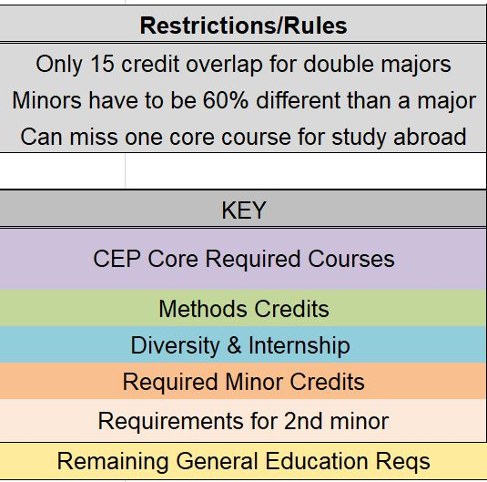

Major: Community, Environment, & Planning (CEP)
Minors: Chinese (CHIN) and Environmental Studies (ENVIR)
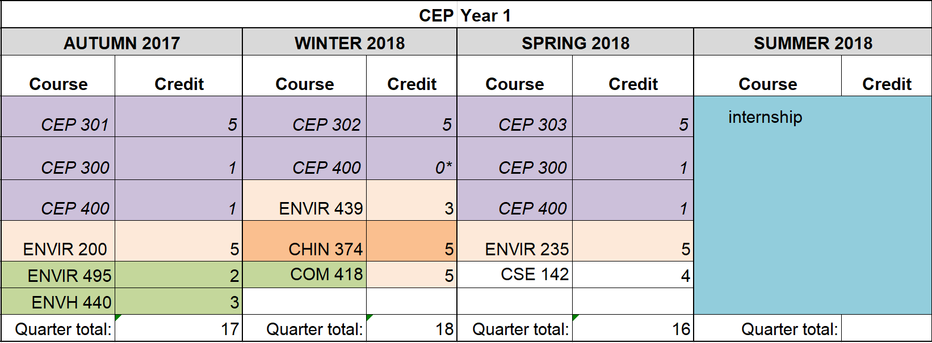
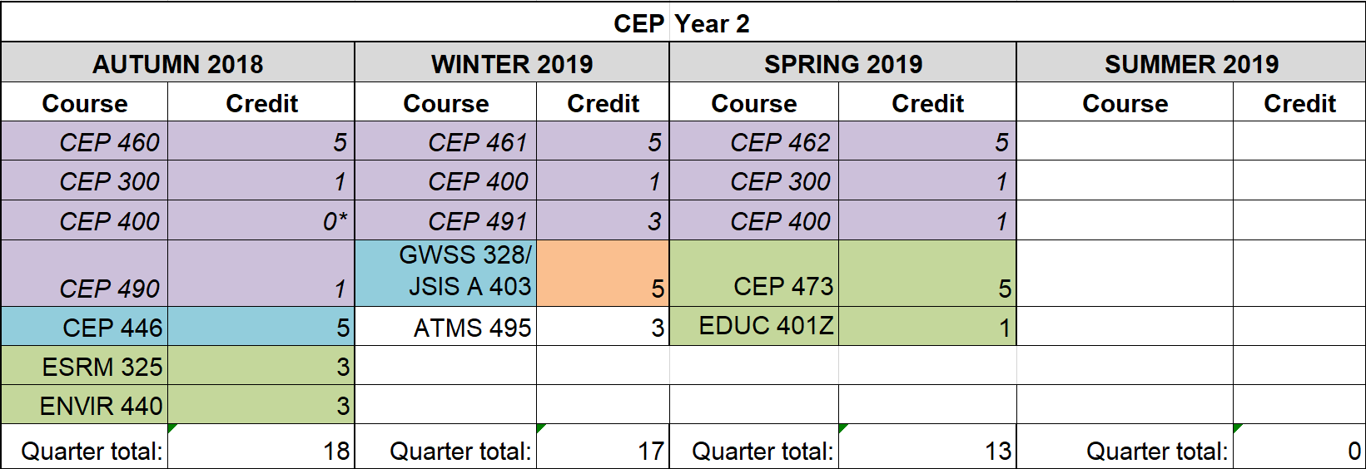
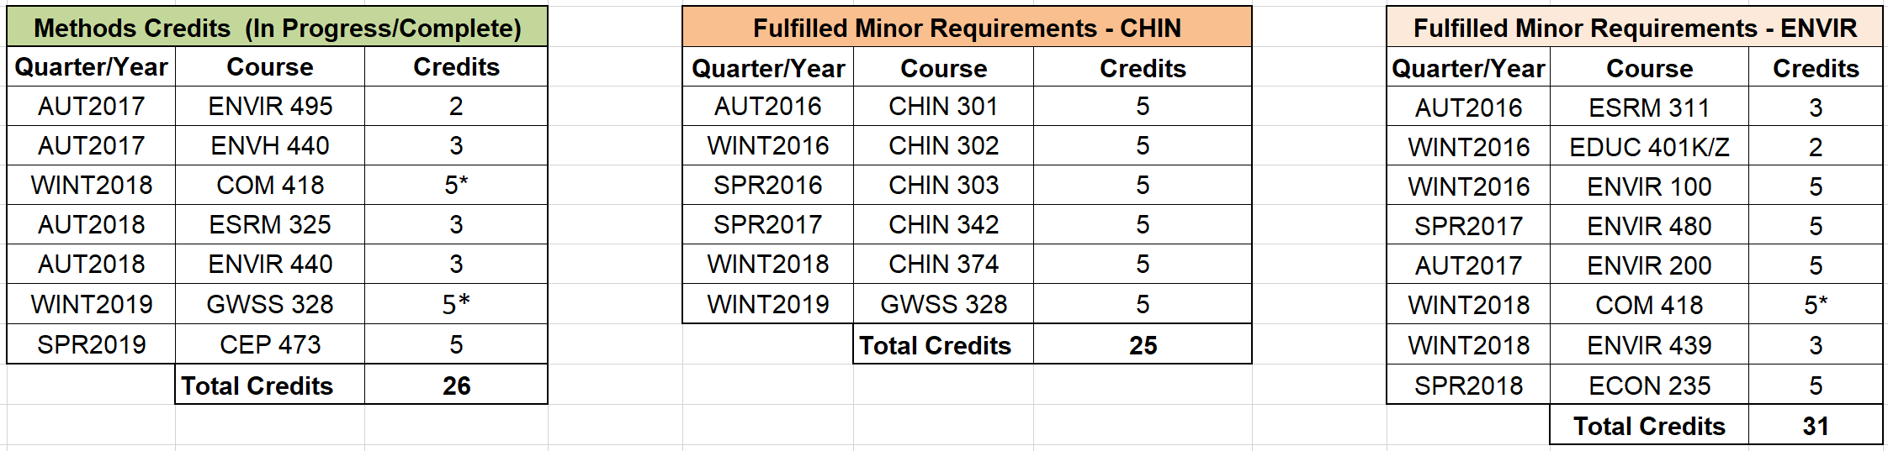

Autumn 2017 (17 cr.)

CEP 301 - The Idea of Community (5 cr.) – Core Course
CEP 301 is a philosophy course which introduces several important philosophers and their corresponding ideas, all of which had significant impacts on the development of Western society, thought, and culture.
In this course I learned about different ideologies, theories, arguments, and beliefs held by some of arguably the most influential Western philosophers and thinkers in history. Many of these ideologies, beliefs, and trains of thought still persist and influence Western social thought, society, and policy today. This course helped me better understand the underlying thoughts and origins of Western thought and society and why such beliefs and systems still exist and persist today.
ENVIR 200 - Communication for Environmental Studies (5 cr.) – Minor (ENVIR)
ENVIR 200 is a writing communication course which develops skills in analyzing, interpreting, evaluating, and responding to different forms, genres, and topics of environmental texts and media.
This course exposed me to different forms, styles, and types of writing found in the environmental field, including but not limited to nature writing, environmental policy, and environmental news. I not only learned how to analyze and utilize different types of environmental writing, but also how to write effectively in these styles and formats.
ENV H 440 – Water, Wastewater, and Health (3 cr.)
ENV H 440 is an environmental health course covering topics surrounding the systems, laws, sources, supplies, treatment, and health risks associated with drinking water, recreational water, and wastewater.
In this course I learned the structure, functionality, and challenges to different drinking water and wastewater systems. In doing so, I also learned about the basics and fundamentals of human and public health and gained an understanding of how interconnected public health, environmental issues, and environmental justice are.
ENVIR 495 – Pre-Study Abroad Seminar (2 cr.)
ENVIR 495 is a pre-requisite seminar for the study abroad program, Sustainability and Personal Choices in the US and China, held during the 2017 Winter Break and led by UW faculty member Kristi Straus. This seminar prepares students for the study abroad program by discussing program logistics, learning about cross-cultural differences, and providing support for visa applications.
This course helped me prepare both logistically, mentally, and to some extent, culturally, for the study abroad trip I attended during December 2017. I learned and reviewed some basic Chinese and Chinese cultural norms, as well as learned some of the basic beliefs and approaches to sustainability by the Chinese government and the Chinese people/Chinese culture and society.
CEP 300 – CEP Retreat (1 cr.) – CEP Requirement
CEP 300 is a course held during a weekend retreat with the other members of the CEP major. It gives students a focused time and space to plan and prepare projects and goals for the CEP major for the upcoming year and further future.
During the CEP retreat, I learned more about myself and my peers in CEP by discussing and sharing our goals and plans for the year and our time in CEP. I also gained a better idea of what was expected and planned in my governance committee and other committees. Finally, I started developing familiarity and practice with certain skills, such as group discussion, achieving consensus, collaborative brainstorming, goal-setting, and organizational planning.
CEP 400 - Governance Practicum (1 cr.) – CEP Requirement
CEP 400 is a once-weekly course in which students work collaboratively and collectively to accomplish tasks for the major as a whole through individual committees, each which focuses on a different task of the CEP major. This committee work is followed by a larger meeting of the entire major or of the different classes, where announcements and opportunities are held.
Similar to the CEP retreat, Governance helps me develop valuable workplace and collaboration skills, such as time management, project planning, work delegation, and teamwork communication.
During this quarter, I worked with the Communications Committee. I learned some basic graphic design and website skills, in particular I learned the basics of Adobe InDesign, Adobe Illustrator, and Wordpress. I believe that gaining proficiency in these software technologies will be a large asset to any professional skillset.

Winter 2018 (18 cr.)*

CEP 302 – Environmental Response (5 cr.) – Core Course
CEP 302 is a course exploring issues of environmental issues and the subsequent societal responses using readings and analysis of different environmental literatures and case studies. CEP 302 aims to develop an understanding of how to use community-based efforts to create a more sustainable society.
In this course I learned some basic fundamentals of scientific thought and practice and gained experience in analyzing and critiquing environmental and environmental health-related issues, systems, and situations, such as the Flint Water Crisis (water infrastructure), wildlife corridors (wildlife management and climate change), and EIS statements (NEPA policy). I feel that the knowledge and experience I gained can be later applied when I work with communities to solve environmental issues.
COM/ENVIR 418 – Communication and the Environment (5) – Methods
COM 418 explores and examines how communication of the environment influences individuals’ beliefs, values, and approach towards the natural world. Within the course, students will learn about environmental news coverage, media strategy and rhetoric used by different stakeholders and entities in relationship to environmental issues, representations of the environment in popular cultures, and political argumentation on environmental policy.
In this course I learned about different ways in which the environment is portrayed in different types of media and what strategies are used in different forms of environmental media and messaging and in what ways these are and are not effective. I believe that COM 418 helped me better understand how society, business, and culture view and present environmental issues and topics, as well as how environmental advocates do so. This knowledge will help me better understand how to communicate environmental issues to the public and what kinds of messaging the public has been more likely to encounter.
ENVIR 439 – Attaining a Sustainable Society (3 cr.) – Minor (ENVIR)
ENVIR 439 discusses and explores environmental issues and challenges across historical time scales in order to understand and discover integrative approaches to environmental protection in the long-term interests of human societies.
In this course I gained a better understanding of how sustainability is viewed and approached by environmentalists on a societal scale. Furthermore, I gained a better understanding of the societal, as well as cultural and economic, challenges that make implementing sustainability on societal scales more difficult. I feel that this course helped me better prepare and understand how to implement and frame sustainability as a policy, practice, and social belief.
CHIN 374 – Chinese Prose (5 cr.) – Minor (CHIN)
CHIN 374 introduces, reviews, and discusses selected pieces of Chinese prose, including historical works, short narratives, essays, and rhyme-prose. All texts are provided in translated English.
In this course I read, analyzed, and learned more about some of the most important texts in Chinese prose and how these texts and their themes and messages have influenced Chinese society, culture, and social thought in the past and present. This course helped me better understand aspects of Chinese culture and thought and have helped me better understand certain Chinese media and Chinese social thoughts and beliefs, which may prove useful when interacting with others from China or possibly even other cultures.
CEP400 – Governance Practicum (1 cr.)* – CEP Requirement
I remained in the Communications Committee. This quarter I greatly increased my skills and proficiency in Adobe Illustrator in designing the Graduation invitation for the 2018 Senior Graduation.
For further details, refer to Autumn 2017.

*I took a 19 credit course load but only registered for 18 credits. In order to prevent going over the quarterly credit limit, I waived the CEP400 course credit, but still participated in Governance.
Spring 2018 (16 cr.)

CEP 303 – Social Structures and Processes (5 cr.) – Core Course
CEP 303 focuses on the development and application of social structures and processes within the contexts of community and environment and how patterns and institutions of social organization and social relationships within different sectors are used.
This course was my first planning course and thus helped me gain understanding of many basic planning fundamentals and concepts, especially in context to neighborhoods, local communities, and cultures, and what planning features and strategies can benefit or work most effectively these groups. The final project of this course was particularly impactful, helping me gain and develop skills in community outreach and surveying as well as helping me gain insight into what issues are often discussed in neighborhoods and communities.
ESRM 235 – Introduction to Environmental Economics (5 cr.) – Minor (ENVIR)
ESRM 235 introduces basic economic concepts, with a focus on environmental and natural resource economics. In addition to covering fundamental economic concepts such as markets, private property, etc., ESRM 235 also introduces common tools used in the economic assessment of environmental issues and how to apply these methods to contemporary environmental issues.
After learning about these concepts in ESRM 235, I gained a better understanding of the economic challenges, barriers, and arguments made around environmental issues and how economic policy and beliefs can prevent or help environmental policy pass. I think this knowledge can be applied in the future when working to educate others about environmental issues, change their mindsets, and even in implanting or developing environmental policy and programming.
CSE 142 – Computer Programming I (4 cr.) – Elective
CSE is an introductory course on computer programming, covering topics such as procedural programming, basic control structures, file processing, arrays, and object definition.
Although I do not plan on going into a career around computer science, informatics, or information-technology, I believe that in today’s technology-driven and dependent society, the basic skill set of computer programming I learned will prove useful and applicable to any workplace and position, as well as serve as a useful foundation for other skills I may develop or wish to develop later, such as website design or GIS.
CEP300 – CEP Retreat (1 cr.) – CEP Requirement
The spring retreat is shorter than Fall Retreat, and is focused more on reflection than planning.
For further details, refer to Autumn 2017.
CEP400 – Governance Practicum (1 cr.) – CEP Requirement
This quarter I continued developing my skills and experience with Adobe Illustrator in the Communications Committee by working on creating other materials for the CEP 2018 Graduation.
For further details, refer to Autumn 2017.

Summer 2018 (0 cr.)
During the summer of 2018, I did not choose to take any summer courses. Instead I spent the summer working in an internship at the Los Angeles Office of the Santa Monica Mountains National Recreation Area (SAMO), under the National Park Service (NPS). This internship fulfils the internship requirement of the CEP major.
See the internship page for further details.

Autumn 2018 (18 cr.)*

CEP 460 – Planning in Context (5 cr.) – Core Course
CEP 460 provides a hands-on approach to learning fundamental skills, approaches, and foundational concepts that apply to and are utilized in city and urban planning. CEP 460 does this by giving students the opportunity to work with city staff on a planning-related project.
Although I do not plan on pursuing planning as a career interest, planning is still an integral part of many environmental and community-based work, and within many larger projects, I will have to apply planning-related thinking, approaches, and skills if I want to reach the best balance between the stakeholders, government, company, and community members. The project I personally worked on was focused on researching and best practices development for a building energy benchmarking program in Bellevue. Through this experience, I developed and built upon valuable project management and teamwork skills.
CEP 446 – Internship (5 cr.) – CEP Requirement (Internship)
CEP 446 is a course which is required to be taken during or after the CEP student completes their internship. This course encourages students to think deeply about their internship experiences and further prepare them for a post-college career and extra-UW opportunities through assignments and lectures around career planning and preparation.
This course really encouraged me to think intentionally about and prepare for my career path after I graduate from the University of Washington. I gained valuable advice, insight, and knowledge in how to look for a job, prepare for interviews, and advocate for myself. Furthermore, this class encouraged me to reflect on my past and current experiences and achievements and think about how I can explain and advertise these experiences and the skills I gained from them for a future career.
See Summer 2018 for a brief description of my internship and the Internship page for a more detailed description.
CEP490 – Senior Project Prep Seminar I: Research & Project Scoping (1 cr.)
– CEP Requirement (Senior Project)
CEP 490 is the first course to the CEP senior project course series. It focuses on the conceptualization and planning stages of the project, including project selection, literature review, plan development, and finding a project mentor.
In addition to providing a strong foundation and support for the start of my senior project, CEP 490 helped me develop important skills and gain valuable experience around how to plan and begin implementing a project, particularly on how to transfer my passions and ideas into a plan for action. During this course, I also further developed my research skills, particularly in the context on an independent project where I had no one to direct me on where to look or what to focus my research on. I believe that these skills will be very valuable and applicable after my time at CEP when I will start and manage my own projects within the workplace.
ESRM 325 – Environmental Applications of Plants: Bioenergy & Bioremediation (3 cr.) – Methods
ESRM 325 gives an overview of the methods, challenges, benefits, and strengths of applying plants as means to solve critical environmental issues—primarily pollution, through plants as a re-mediator of contaminated land and as a source of bioenergy.
Although I do not plan on working in the energy sector or in remediation and land reclamation, I believe such methods of using plants as bioremediators and for bioenergy will become increasingly more important as our societies increasingly look for more sustainable sources of energy and sustainable ways in which to treat our waste and recover valuable contaminated land. Furthermore, this course helped me think in new ways when it comes to alternative energy and how we can use resources in multiple ways. I believe that the knowledge I gained in this course is generally beneficial information to know as an individual going into the environmental field and that it will become increasingly applicable in the future.
ENVIR 440 - Environmental Pedagogy (3 cr.) – Methods
ENVIR 440 teaches students about pedagogy, the study of teaching, with an environmental and ecological lens. In doing so, students think intentionally about what it means to learn from others and teach others as well as reflect on their own learning and teaching experiences, and then discuss what methods and approaches can be used to best help students learn.
Although the focus is on pedagogy using nature and the environment as a subject of and tool for learning, this course was not exclusive to learning about the environment or teaching environmental topics. I felt this course taught me vital skills in how to teach and work with others which will be valuable outside the direct classroom settings and be applicable into larger communication, community-development, and education-programming settings that I will encounter in my future career.
CEP300 – CEP Retreat (1 cr.) – CEP Requirement
Refer to Autumn 2017.
CEP400 – Governance Practicum (1 cr.)* – CEP Requirement
During this quarter, I worked with the Community, Equity, Committee (CEC). I primarily worked to develop and propose new CEP policies regarding a Preferred Gender Pronouns Policy (PGPP) and a Native Land Recognition Policy (NLRP). In working on these policies, I further developed my writing, team work, and collaboration skills as I had to work with several other CEP students to develop, write, and revise the policies.
For further details on the general Governance structure, refer to Autumn 2017.

*I took a 19 credit course load but only register for 18 credits. In order to prevent going over the quarterly credit limit, I will have to waive the CEP400 course credit, but still participate in Governance.

Winter 2019 (17 cr.)

CEP 461 – Ethics and Identity (5 cr.) – Core Course
CEP 461 examines personal, societal, institutional ethics through the analysis and discussion of foundational Western ethical works, including but not limited to Plato, Kant, Mill, and Hume. In the process, students build their own views and understanding of different identities and views on a greater sense of humanity, what constitutes right and wrong, and what right and wrong may even mean, despite these diverse identities.
Regardless of my career path, I will inevitably interact, work with, and serve a diversity of people from different backgrounds, all of different beliefs, experiences, and identities. This course will allow me to develop a better conceptual understanding and context of these diverse identities and belief systems, how to best approach and invite them into shared spaces, and work with them collaborative and productively, even if we have different opinions, beliefs, and values. Furthermore, understanding the basis of different primary ethical ways of thoughts will most likely prove useful in the future in working with others on projects which may involve considering hard ethical questions and working towards the solution or decision.
GWSS 328 – Gender and Sexuality Studies in China (5 cr.) – Diversity requirement, Methods, MINOR (Chinese)
GWSS 328 explores the changes in the perception and approaches to gender and sexuality in China from different historical, anthropological, and cultural lenses, particularly considering the effects of western colonialism and Chinese modernization.
As China continues to rise as a global superpower, it is also modernizing and its culture rapidly changing. Among these changes is its changing identities and perceptions of gender and sexuality. As I am interested in potentially working and studying in China, it is important I am aware and informed about the cultural differences and changes in China, including those around gender and sexuality, as these have been historically and culturally sensitive topics. Even if I do not ultimately work in China, I have learned new perspectives, ways of thinking, and more about systems, patterns, approaches, and institutions of oppression and expression. I think in a world which is complex and imperfect, being aware and mindful of such topics is very important, especially in any position where I may influence other’s experiences or lives in meaningful ways.
ATMS 495 – Special Topics in Environmental Studies: Earthgames (3 cr.) – Elective
ATMS 495 was a studio course where a team of UW students work together and collectively use their skills to design, create, and implement an environmentally-focused digital game.
Although this course was mainly focused on game design, development, and creation, of which I do not plan on pursuing a career in, this course really helped me develop my teamwork, project management, collaboration, and project planning skills. This course was also a powerful experience because our team was composed of students from a diversity of backgrounds and special skill sets of which I had never worked with before and it was a challenging but positive experience to learn how to work with others with such different skill sets, work styles, and expertise to together create a final product.
CEP491 – Senior Project Prep Seminar II: Methods & Actualization (1 cr.)
- CEP Requirement (Senior Project)
CEP 491 is the second course to the CEP senior project course series. It focuses on the implementation stages of the senior project. For my project this included revision of the initial proposal and plan, continued research, coalition recruitment, hip building, and policy proposal writing.
This course was not only essential to the completion of my senior project, but it also helped me develop applicable skills around project planning, revision, management, evaluation, and implementation that I will use when I manage and plan my own projects in my future career. It also helped me learn and develop outreach, recruitment, and coalition building skills, of which I had limited experience in before but I am positive I will utilize in the future career.
CEP400 – Governance Practicum (1 cr.) – CEP Requirement
During this quarter, I worked with the Community, Equity, Committee (CEC). I primarily worked to develop and propose new CEP policies regarding a Preferred Gender Pronouns Policy (PGPP) and a Native Land Recognition Policy (NLRP). In working on these policies, I further developed my writing, team work, and collaboration skills as I had to work with several other CEP students to develop, write, and revise the policies.
Furthermore, I facilitated the Forum session for the proposal of these policies to the major and led the voting process. This helped me improve my facilitation skills and helped me practice my presentation and public speaking skills.
Finally, during this quarter I also worked several other CEC and non-CEP UW students to plan the 2019 UW Earth Day event. Doing so helped me further develop my evet-planning, project organization, time-management, and collaboration skills.
For further details on the general Governance structure, refer to Autumn 2017.
Spring 2019 (17 cr.)

CEP 462 – Community and Environment (5 cr.) – Core Course
CEP 462 is the culmination course of the core courses of the CEP major as well as combination of the accumulated knowledge and skills of the major with community field experiences. In addition to finishing their senior project, students reflect, synthesize, and apply their knowledge and skills learned in the major to then discover their own philosophies around community and environment within different, meaningful contexts.
CEP 462 will acts as a great culmination to the end of my CEP education, refreshing and reapplying all that which I have learned and gained within my time in the major. The philosophies which I develop and discover in this course will help me best understand how I want to address issues and concepts around community and environment in my life moving forward after my time in CEP.
CEP 473 – Digital Design Practicum (5) – Methods
CEP 473 is a digital skills and software course which teaches students the basics and foundational skills in several key digital design software used in city and urban planning, including GIS software (ArcGIS), basic modeling (SketchUp), rendering (Lumion), and the Adobe Suite (Photoshop, Illustrator, InDesign).
Although the software skills were mainly taught with a focus in application towards planning, I believe that the digital skills I gained in this course will still prove very useful although I do not plan on pursuing a career in urban or city planning. In particular, I believe that this course has taught me basic fluency in the key design programs Adobe Photoshop, Illustrator, and InDesign, which I can use in any future career to do basic design work. This can translate to use in outreach, recruitment, project organization and planning.
EDUC 401Z – Empowered Eco Education (1 cr.) – Methods
EDUC 401Z is an education practicum course where students develop an environmental and/or science-focused lesson plan for elementary school students and then get the opportunity to teach their lesson plan to elementary school students on a weekly basis. The elementary school students have traditionally been students who go to school in South Park, Seattle, a neighborhood which experiences environmental pollution and environmental injustice.
This course allowed me to develop and improve my skills in environmental education, environmental communication, and also how to work with and communicate with different and diverse audiences. I believe that experience working with diverse audiences and audiences who do not have much of a science or environmental foundation will be very important in my future career path which is oriented towards the environment, education, and community development. Furthermore, I was facilitator for this course, not just a student. As facilitator, I had to take on additional responsibilities, such as purchasing lesson plan supplies, reviewing and editing curriculum, leading seminar sessions, and coordinating transportation and course logistics. Acting as a facilitator helped me improve several valuable skills such as communication, organization, time management, project planning, and leadership.
*note: Although I took this course for 1 credit, it was a 3-credit workload, especially considering that I had to do additional work as the course facilitator.
CEP300 – CEP Retreat (1 cr.) – CEP Requirement
Refer to Spring 2018.
CEP400 – Governance Practicum (1 cr.) – CEP Requirement
During this quarter, in the first half of the quarter, I focused on planning for the 2019 Earth Day event with several CEC members and non-CEP UW students. This quarter, I worked primarily in volunteer coordination and day-of event organization. This helped me further develop my project planning, event-organization, teamwork, and leadership skills.
In the second half of the quarter, I focused on working to update the CEP Strategic Equity Plan and continue work on the Preferred Gender Pronoun Policy and Native Land Recognition Policy. Since these projects were also occurring as the end of my time at UW approached, working on these helped me work on time management in addition to teamwork, organization, and facilitation skills.

Internship

In the summer of 2018 I interned with the National Park Service (NPS) at the Los Angeles Urban Outreach Office under the Santa Monica Mountains National Recreation Area (SAMO). This internship was secured through the internship program, Future Park Leaders (FPL), which is run by both the NPS and University of Washington.
The primary tasks of my internship was to develop and conduct community-based facilitated dialogues with different urban communities and communities members, particularly focusing on communities which are marginalized, under-served, and have historically faced environmental injustice and poor access to parks and green space. These dialogues were to be focused on connecting environmental, sustainability, and climate change to community concerns such as healthcare, education, clean water, etc. In addition to conducting dialogues, I was also tasked with partnering with local museums on similar programming.
During my internship, I developed and conducted three community-based facilitated dialogues. The first dialogue covered topics of public land and green space access with a group of high school students in a program trying to encourage stewardship and interest in public lands. The second dialogue covered topics of climate change and its affects and relationship to local communities with a group of adult community members adjacent to the LA International District. The final dialogue was conducted in Spanish with the help of a bilingual partner and covered topics of public lands and climate change with a group of Spanish-speaking senior citizens at a local community center. In addition to the dialogues, I worked with the local Chinese American Museum (CAM) and the Museum of Social Justice (MoSJ) on programming connecting sustainability to the Chinese American community of the past and present and programming detailing the effects of climate change on the homeless population in Los Angeles.
When I was not working on my main project, I helped NPS staff with general education and outreach activities and program development. Most of these activities were related to informing urban communities about SAMO, teaching children about the environment and natural science, and exposing urban children to different aspects of National Parks such as wildlife (e.g. through pelts), Native cultures (e.g. through artifacts), and recreational activities (e.g. climbing, fishing).
I found this internship very rewarding and insightful. I learned how to better communicate with and work with diverse audiences and communities, and I gained a fresh perspective on community development and empowerment. In addition, I gained experience and insight into new ways to approach environmental education and community development. I feel like the communication, organization, and outreach skills I gained in this internship, in addition to the experience working with so many different people, will be invaluable for me in the future. This internship also has inspired me to more seriously consider working in the fields of environmental education, urban community development, and environmental justice and access.
Senior Project

For my Senior Project, I developed and began implementing a plan on how the University of Washington (Seattle campus) could feasibly implement and install a mandatory sustainability course graduation requirement. This plan was based, at least in part, after the successful initiative to require a mandatory diversity course completion to graduate from the University of Washington, passed in 2013. Initially, I planned for my Senior Project to not only outline steps on how the sustainability graduation requirement policy could be imposed and passed, but I also planned that it would incorporate feedback and suggestions from UW student and faculty focus groups on what this sustainability graduation requirement could look like and how it could be implemented. Instead, after researching and speaking with several UW staff and faculty, I ultimately pivoted my project towards building a student coalition to support and continue the project after I graduate. Although, in the process, I still talked with many UW students as well as several UW faculty and staff for advice, feedback, ideas, and support. Furthermore, I submitted and passed a resolution to the Associated Students of the University of Washington (ASUW), the student body government at the University of Washington, asking for their support in the consideration of a sustainability graduation requirement.
I chose this project because I believe a sustainability graduation requirement is important not only because I believe that an awareness and knowledge of sustainability is important and related to every field of study and every career, but also because I feel such an initiative aligns strongly with the University of Washington’s recent initiatives to present itself as a green, sustainable university. I believe that the UW cannot claim to be truly pursuing sustainability if it primarily tries to approach sustainability from an infrastructural standpoint (i.e. constructing green buildings). I believe education and member awareness and support are critical parts of a university which should be considered in judging how “sustainable” a university (or organization) truly is.
This senior project connects to my interest in environmental education, although it focuses more on a policy approach than the actual act of environmental education itself. On a larger scale however, this project is connected to my interest and belief in environmental issues, sustainability, and how we can better connect others to these topics and communicate how interdisciplinary and relevant these topics are to their lives, interests, and fields of study and work. Although by no means the only, or even best, way to communicate and educate others about sustainability and environmental issues, I believe implanting a sustainability graduation requirement is one step that can be taken in the right direction and can introduce others who might otherwise have not been exposed to these topics to ideas which may get them connecting and relating to sustainability and the environment.

Study Abroad and Extracurricular Activities

Study Abroad
I have already studied abroad with different University of Washington programs, and a few times during the summer when I was in high school. I primarily studied Mandarin language and Chinese culture in China. In the summer of 2017, I traveled to Greece to learn about immigration, migration, the Syrian refugee crisis, and the perception of the Roma people in Greece. The winter of 2017, over winter break, I traveled to Beijing for a couple weeks to study how the people and city of Beijing approach sustainability, in terms of infrastructure and individual actions.

Extracurricular Activities
UW Earth Club
During my junior year and part of senior year, I acted as the president of the UW Earth Club. Earth Club is a social and club which focuses on expressing environmentalism through different avenues, from everything to restoration work to activism to outdoor activities to eating out at sustainable restaurants. Acting as president of Earth Club was often stressful, but overall it was a valuable learning experience where I gained experience in meeting coordination and organization, project planning, task delegation, and leadership.
Empowered-Eco Education
Related to Earth Club is a course called Eco-Empowered Education. It is part of the UW Pipeline Project and is a section under the course number EDUC 401. It involves teaching elementary students at Concord Elementary, located near the polluted Duwamish River, about science and environmental topics. Members of Earth Club have historically led this course, and I led this course for the past two years in the spring. Leading and facilitating this course has been challenging, but a rewarding experience. I have developed many skills in facilitating this course, including but not limited to project planning and organization, facilitation, time management, curriculum development, and communication.
For more details, see Spring 2019.
UW Earth Day
For the past two years I have also been a member of the student committee planning the annual UW Earth Day celebration. The first year I became involved as a representative of Earth Club and the second year as a representative of the CEP Community Equity Committee.
The UW annual Earth Day event is one of the biggest and most expensive events that I have ever participated in planning and these events, especially in 2018, were primarily entirely student planned and led. Though my participation in planning these two Earth Day events, I gained valuable insight into the project-planning and event-planning process, often witnessing or working on in some manner every step involved, from grant-writing, facilities, and entertainment. My particular role was volunteer recruitment, organization, and management. Overall, through these experiences, I developed skills in event planning, project management, leadership, and volunteer coordination.

Employment
In addition to my summer internship, I also worked during the school year. The work I would like to most highlight was my time at Computing Kids, a non-profit which offers after-school coding courses to students in the Seattle School District. Through Computing Kids, I learned some basic coding concepts, designed coding curriculum and lesson plans, and helped teach elementary school students fundamental coding concepts. This position helped me further develop skills in curriculum development, teaching, communication, and classroom management.

